26.71: a) With an open switch:
Also, there is a current in the left branch:
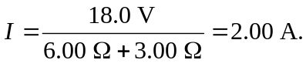
So, 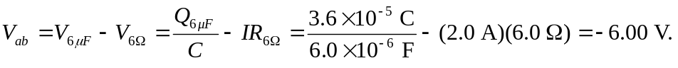
b) Point “b” is at the higher potential.
c) If the switch is closed:
d) New charges are:
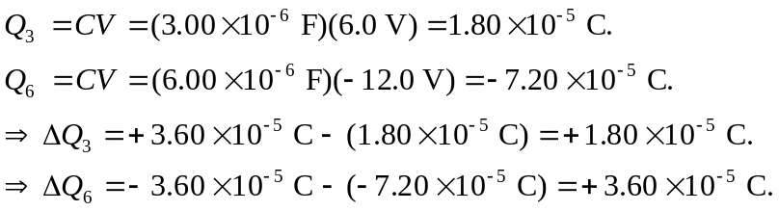
So the total charge flowing through the switch is 